Project 0 - Legged Locomotion Robot

EECS 464 - Winter 2018

**Final Report**

February 9, 2018

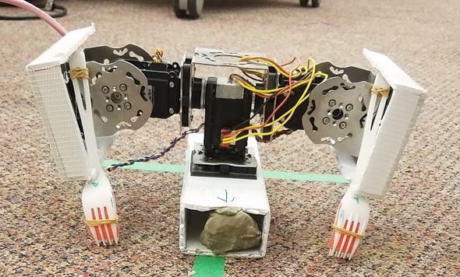

Team Blue:

Royce Chung

Anne Gu

Mukai Wang

Ali Yassine

Course Instructor:

Prof. Shai Revzen

**TABLE OF CONTENTS**

|  |  |
| --- | --- |
| 1. Background …..…………...………………………………………………….... | pg. 2 |
| 1.1 Problem Description |  |
| 1.2. Brainstorming |  |
| 1.3. Final Design………………………………………………………………. | s |
| 2. Results ..….………………………….…………………………………………. | pg. 2 |
| 3. Discussion…………….…………………………………………………………. | pg. 2 |
| 4.References ………………………………...…………………………………...... | pg. 2 |

**1. BACKGROUND**

**1.1 Problem Description**

**In LaTeX**

**1.2 Brainstorming**

When reviewing the problem description and brainstorming our robot design, our group looked at prior projects that were successful during P-day.

Reference figures, like Fig.XX, in the text.

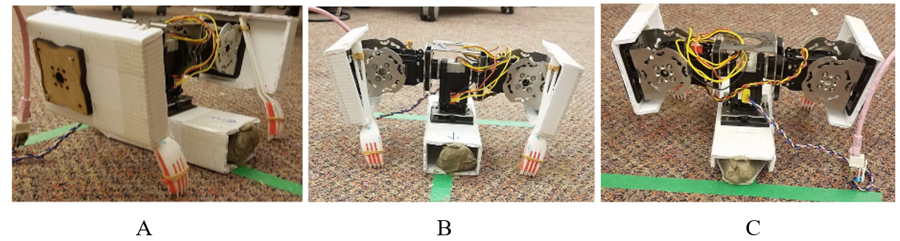

**Figure 1.** Complete robot assembly: A) Side view, B) Front view, C) Back view

**2. RESULTS**

P-day has four different events. First was the qualification round where the robot had to move from one end of the track to the other in a line ignoring the marker tape. The next event was a race around the figure eight track with inner and outer bounds. The third event was the same as the previous, but only the inner bound applied. The last event was a straight race along a 15’ straightaway.

2.1 Qualification

The stra

2.2 Figure Eight Track (Inner and Outer Bounds)

|  |  |  |  |  |  |
| --- | --- | --- | --- | --- | --- |
|  | Trial 1 | Trial 2 | Trial 3 | Trial 4 | Trial 5 |
| Green Team | 134 (DQ) | 143 |  | 111(DQ) | 133 |
| Red Team |  | 76 (DQ) | 67 |  | 63 |
| Blue Team | 160 (DQ) |  | 153 (DQ) | 127 |  |

2.3 Figure Eight Track (Only Inner Bounds)

|  |  |  |  |  |  |
| --- | --- | --- | --- | --- | --- |
|  | Trial 1 | Trial 2 | Trial 3 | Trial 4 | Trial 5 |
| Green Team |  | 140 (DQ) | 110 (DQ) |  | 83 |
| Red Team | 63 |  | 65 | 61 | 44 |
| Blue Team | 151 | 153 (DQ) |  | 166 (DQ) |  |

2.4 15’ Straightaway Race

|  |  |  |  |  |  |
| --- | --- | --- | --- | --- | --- |
|  | Trial 1 | Trial 2 | Trial 3 | Trial 4 | Trial 5 |
| Green Team |  | DNF |  | 38 | 38 |
| Red Team | 39 | 69 | 44 |  | 42 |
| Blue Team | 76 |  | 73 | 54 |  |

**3. DISCUSSION**

**3.1 Final design analysis**

Based on the results at project day, there were two disadvantages to our robot were turning and slipping.

* Turning was time consuming. Takes approximately 7 seconds to turn 90 degrees either right or left. Turns were primarily the reason why we got disqualified so often
  + Improvements can include adding features to the side of the fork, such as bamboo skewers or knives.
* Our robot slipped a lot. Localized, Friction based movements. Especially on tape
  + The back end of the base of our robot, ended up adding a knife at the end to help prevent the slipping. Using the leg padding from the other team, helped us realize that directional friction was needed, but ultimately using the padding prevented us from turning.
* Our robot’s stride length and stride times were slow compared to other teams
  + Our team

**3.1 Project day result analysis**

Words here

**3.2 Future work**

Words here

**4. References**